TCP Client/Server Assignment

Marvin Newlin

14 Nov 18

CSCE 560

1. Provide a screenshot of the **netstat** results showing a listener at port 12000.

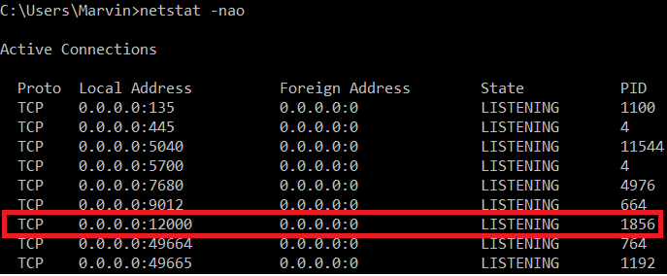

1. Provide screenshots of your server and client Python Shells after the server responds with the capitalized string.

